Lab 2 Placeholder

Workspace Folder Structure
I went to my Workspace folder, created an ArchOSC Assignment folder, and inside it a Pictures folder for screenshots.
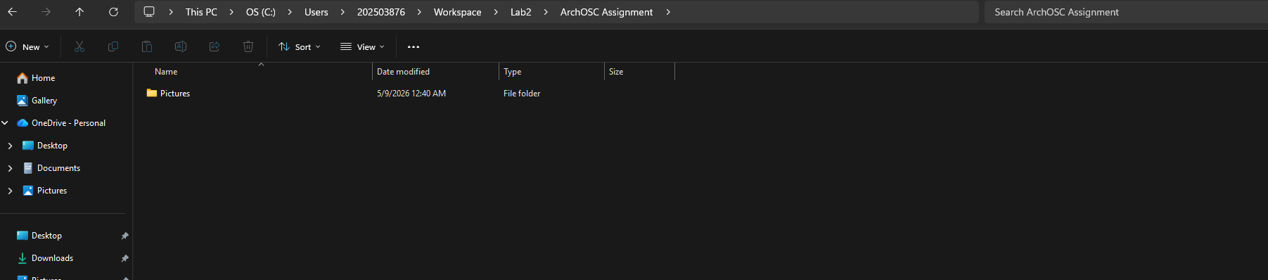

Opening The Terminal
I right-clicked inside my `GitHub and CICD` folder and selected "Open in Terminal", then ran `git init` to create a new local Git repository.
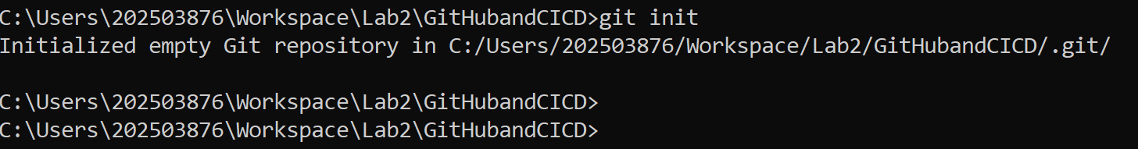

Created GitHub Repository
I logged into GitHub, clicked the green "New" button, and created a private repository named ARCHOSC-Assignment-A-ALKAYYAL with a README file and Visual Studio Git ignore.
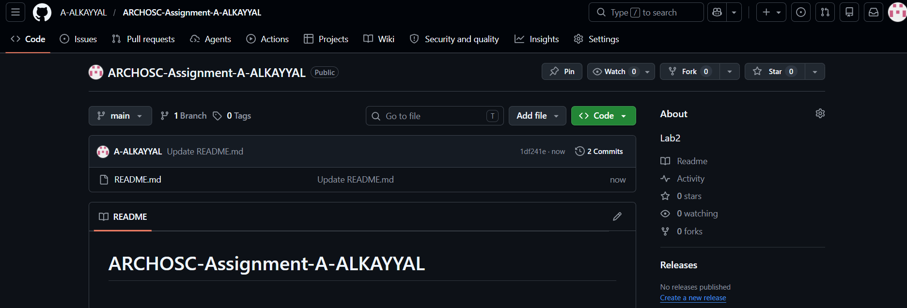
Linking Local Repo to GitHub
I ran git remote add origin https://github.com/A-ALKAYYAL/ARCHOSC-Assignment-A-ALKAYYAL to connect my local repository to GitHub, then used git pull origin main to fetch the README file from the online repo.
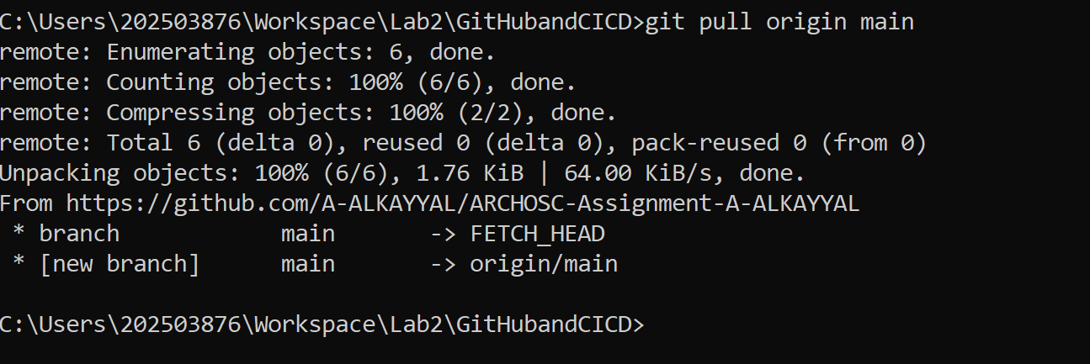
Created Basic Website
I opened VS Code, created a new file, pasted the HTML code, and saved it as index.html inside my workspace folder. I then double-clicked the file to view the website in my browser.
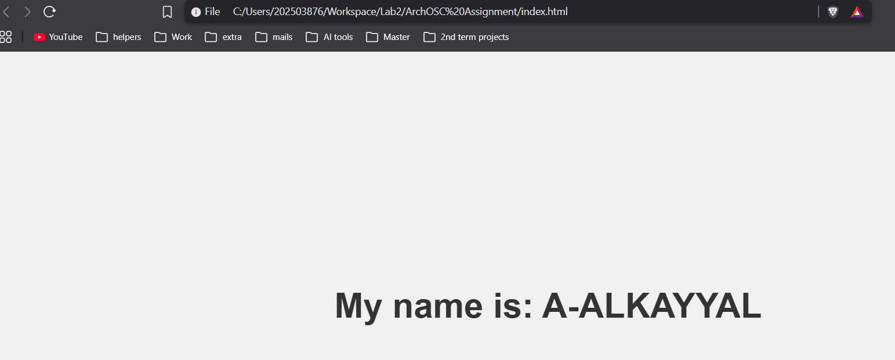

Updated Local Repository
I ran git status to see untracked files, used git add . to stage all files, then ran git commit -m "new files" to save them to my local repository.

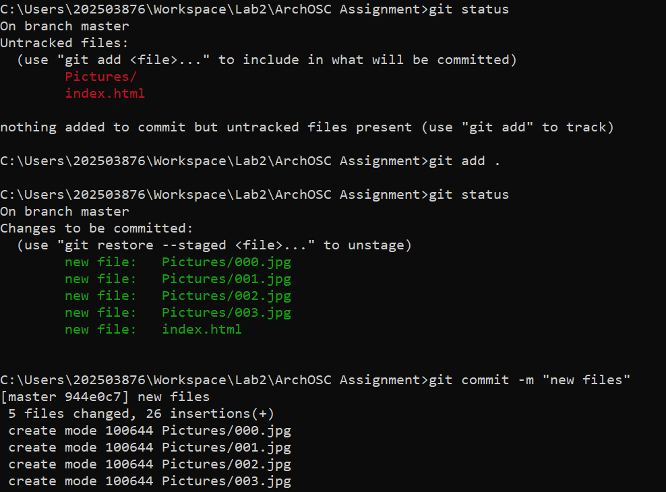
Pushed Local Repository to GitHub
I ran git branch -m master main to rename my branch, then used git push -u origin main to upload my local repository to GitHub.
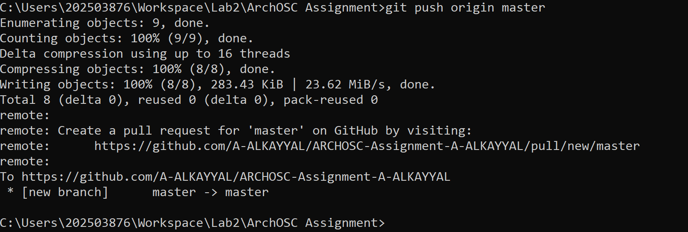
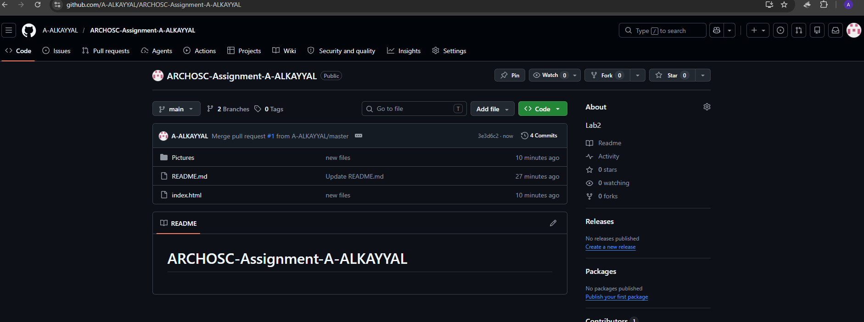

Improve your website.
Change 1 – Gradient Background
Changed solid gray to purple-blue gradient.
Change 2 – Gold Name with Blur Box
Made name gold (#ffd700) and added rounded semi-transparent box with blur.
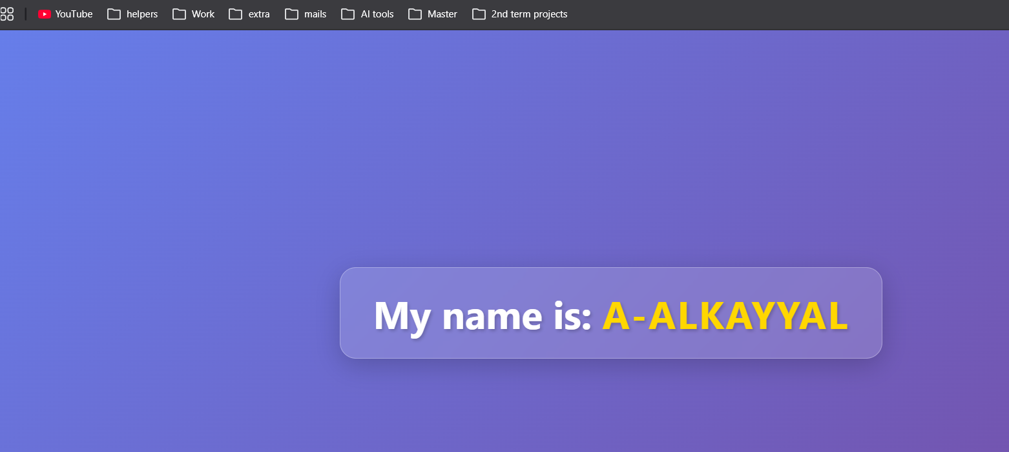
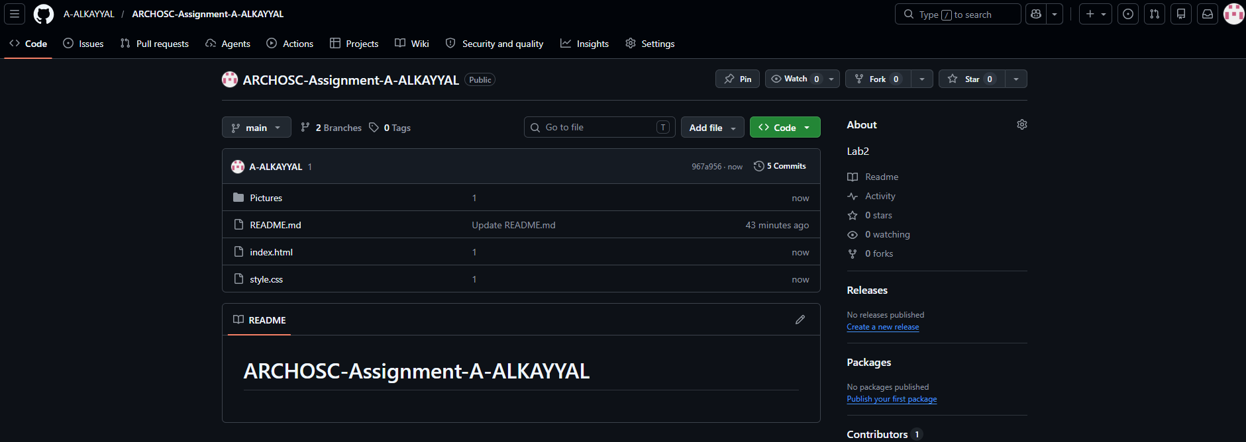

<!DOCTYPE html>
<html lang="en">
<head>
<meta charset="UTF-8">
<meta name="viewport" content="width=device-width, initial-scale=1.0">
<title>Centered Name | A-ALKAYYAL</title>
<link rel="stylesheet" href="style.css">
</head>
<body>
<h1>My name is: <span class="name">A-ALKAYYAL</span></h1>
</body>
</html>

body {
display: flex;
justify-content: center;
align-items: center;
height: 100vh;
margin: 0;
font-family: 'Segoe UI', Tahoma, Geneva, Verdana, sans-serif;
background: linear-gradient(135deg, #667eea 0%, #764ba2 100%);
}

h1 {
font-size: 3rem;
color: white;
background: rgba(255, 255, 255, 0.15);
padding: 1.5rem 2.5rem;
border-radius: 20px;
backdrop-filter: blur(10px);
box-shadow: 0 8px 32px rgba(0, 0, 0, 0.2);
border: 1px solid rgba(255, 255, 255, 0.3);
text-shadow: 2px 2px 4px rgba(0, 0, 0, 0.2);
}

.name {
color: #ffd700;
font-weight: bold;
letter-spacing: 2px;
}

Deployed Website to GitHub Pages
I went to Settings → Pages, set branch to main, and saved. Then I clicked the deployment link to view my live website.
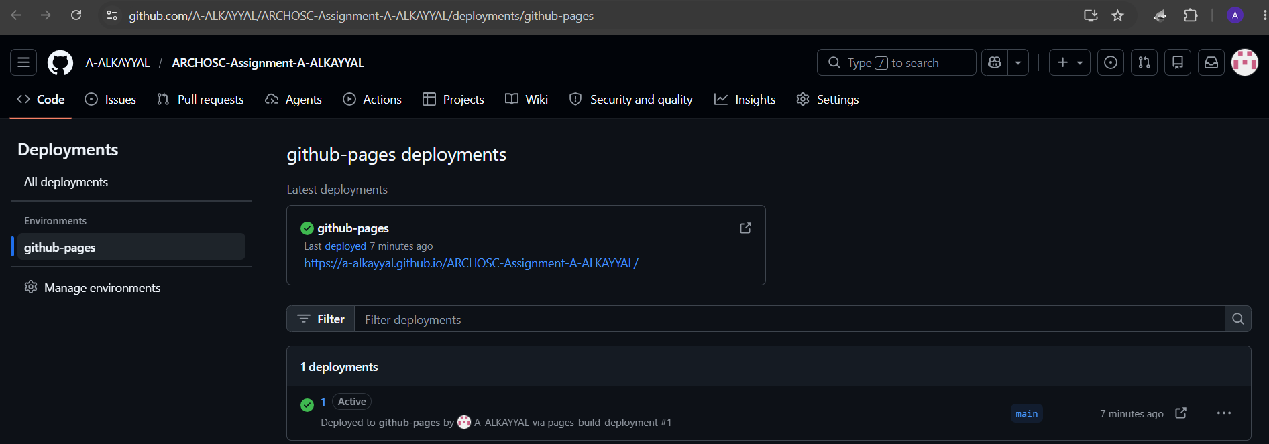
Fixing Private Repository Issue
I accepted the GitHub Classroom assignment, created two local folders (OriginalAssignment and NewAssignment), pulled my old repo into the first and the classroom repo into the second, copied all files from OriginalAssignment to NewAssignment, committed with the message "Ported Assignments", and redeployed to GitHub Pages.
